PROJECT REPORT

Crime scene analysis using drone
BY
Group 8

Shaikh Jaheed AP24110020001
Girisha Varshini AP24110010367
Degala Lavanya AP24110020058
Ram Sai Teja AP23110010118

Submitted to:
Dr. Pranav R T Peddinti
Department of Civil Engineering
SRM UNIVERSITY, AP

ABSTRACT

The main objective of this report is to enhance crime scene investigation with Drone Technology and to explore the potential of Unmanned Aerial Vehicles in streamlining evidence collection and analysis. The present methods for investigating crime scenes are laborious, time-consuming, prone to contamination, and require skilled workers. Drones are a novel tool for crime science investigations. UAVs are versatile tools that can be used to investigate crime scenes. such as taking pictures, recording videos, looking for evidence, evaluating safety, inspecting locations that are hard to reach and so on.
Drones provide a modern and effective option for forensic investigations. They can perform various tasks, such as capturing high-resolution images, recording videos, identifying potential evidence, assessing safety conditions, and reaching areas that are hard or dangerous for investigators to access. One significant benefit of UAVs is their ability to send real-time data to a ground control station, where experts can review the information and guide the investigation process more effectively. Drones also reduce physical interaction with the crime scene, allowing for pre-inspection and mapping of locations before investigators arrive. This helps lower the risk of disturbance or tampering. In recent years, the use of drones in forensic applications, including tele-forensics and aerial documentation, has risen sharply. Drone-based photogrammetry has many advantages over traditional methods that are used for collecting of data, also it increased accuracy, speed, and ensure safety of personals.

Motivation & Necessity

The management of crime scenes and forensic investigations is a complex and time-consuming process that is expose to contamination and Tampering. To solve these issues, an unmanned aerial vehicle (UAV) with functional and operational diversity, can be used. Drone-based photogrammetry, using payloads such as RGB cameras, LiDAR, and also the use of Ground Control Points (GCPs) to increase the navigational accuracy, has proven to be much more accurate and precise than any known traditional methods.

In current time all the crime scene investigation depends mostly on traditional manual methods such as photography, sketches, and ground-based scanning. With the rise in crime and the demand for quicker investigations, there is a strong requirement for sophisticated technology. One way to accomplish this is through the use of drones. Drones limit the amount of human presence at the crime scene and therefore limit the probability of contamination. Drone-based systems reduce human interaction within the crime scene, that indirectly prevents them from being get contaminated.

Drones provide investigators with an aerial view of the crime scene through photographs or videos taken from above and can also be utilized to create 3D representations of the crime scene using photogrammetry and LiDAR. Therefore, drone technology is an outstanding asset to contemporary forensic investigations where precision, expedience, and data preservation are all critical aspects. Drone systems help reduce contamination, allow better documentation, and enable preservation of digital evidence.

Research Design, Methods, and Data Analysis Techniques

This study follows an exploratory research approach combined with case study analysis. Data was collected from simulated crime scenes under both daytime and nighttime conditions to evaluate system performance under different environments.
The analysis focused on two types of parameters:
Quantitative Parameters
- Measurement accuracy and point cloud density
- Time required for data collection
- Cost of equipment
Qualitative Parameters
- Ease of data collection
- Completeness of reconstructed models and impact of environmental conditions

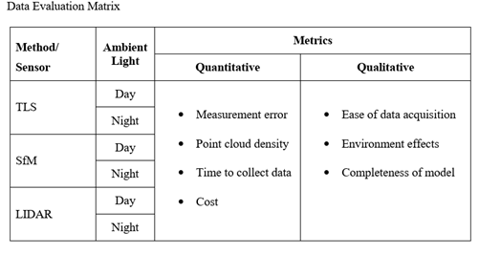

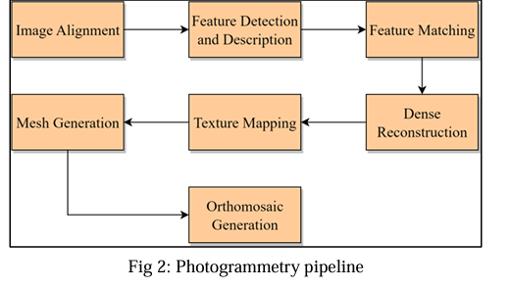
Data acquisition:
Crime scenes can exist in indoor or outdoor environments. In most cases, drones are operated by trained pilots, but autonomous flight planning can also be used.
The data acquisition process includes:
- Feature Detection and Description: Key features are extracted from captured images using algorithms such as ORB, which identify important points and their orientations.
- Tracking: The movement of the drone is tracked using these features to determine its position and orientation.
- Local Mapping: A map of the environment is generated based on the detected features and movement estimation.
- Loop Closing: The system identifies previously visited locations to improve mapping accuracy.
- Bundle Adjustment: Optimization techniques are applied to refine the accuracy of the reconstructed model.

Data processing:

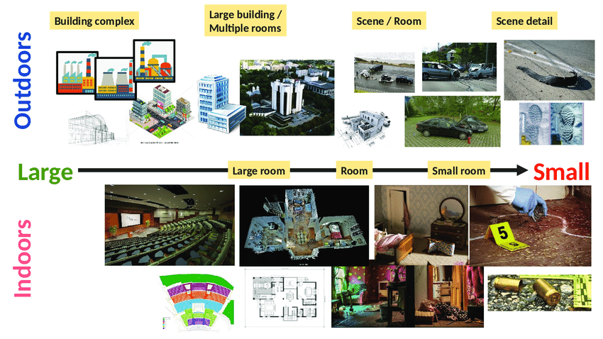
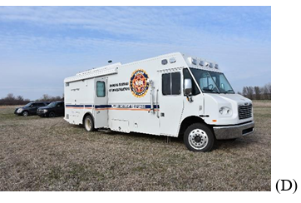
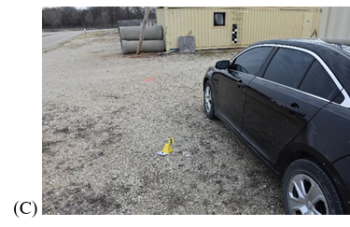
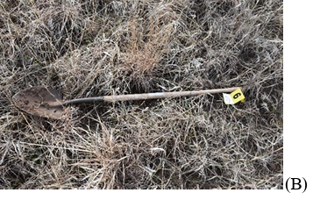
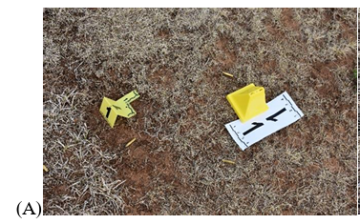
Sample images from crime scenes
(A) Firearm Covering (B) Shovel (C) Broken Glass (D) Incident Response mobile Command Center

Fig.Multi-Scale Crime Scene Mapping from Large Outdoor Areas to Detailed Indoor Evidence

Advantages:
A. Precision and Accuracy
• Better geographic analysis and measurement
• Aerial photos with high resolution
B. Time and Cost Efficiency
- Fast deployment and data collection
- Low labour and transportation cost
C. Safety and Reduction of Risk Factor
- The crime scene is not disturbed and tampered.
- Access to dangerous and unreachable location.
D. Extensive Records and Documentation
- Creating 2D maps and 3D models.
- The long-term preservation of crime scene data for forensic research.

Disadvantages:
- High dependency on weather conditions such as lighting, rainfall, gust wind, moisture etc...
- Due to insufficient illumination during night-time, data collection may fail.
- Sometime it is difficult for LiDAR to detect small objects effectively.
- Requires trained personnel and mission planning and one must take care of all legal and regulatory restrictions.

However, drone forensics has encountered a number of challenges, especially due to the rapid evolution of digital technologies and the increased usage of UAVs in different applications. The main challenges include:
Challenges in crime scene analysis using Drones

Anti-forensics: This is a major challenge in which people use different techniques to avoid detection of any evidence. The techniques include wiping unused storage space, hiding data, changing file extensions, and altering timestamps. The attackers may also use techniques such as denial-of-service attacks on the tools and techniques used in the investigation process.
Strict legal regulations: As the usage of drones has increased, it is necessary for the government to impose strict regulations for the usage of drones in a safe and legal manner. The Civil Aviation Authority has provided guidelines in the form of the Drone Code and Air Navigation Order for the usage of drones in the UK. In addition, the manufacturers of drones also provide information regarding the legal guidelines for the usage of drones in different regions of the world.

Key Challenges Include:
• Anti-forensics techniques
• Vulnerabilities in tools and techniques
• Strict legal regulations and no fly zones
• Need for awareness regarding guidelines and regulations
Methodology and Experimental Setup
Based on previous research, some of the critical challenges identified in the use and deployment of drones in real-world scenarios, especially in forensic and mapping, include the need for a skilled drone pilot, which makes the operation more complex. Secondly, the use of drones in indoor scenarios has been a challenge, especially because of the unavailability of GPS signals. Lastly, the issue of obstacle avoidance has been a critical challenge, especially in complex scenarios, where the chances of collision can be a problem.
However, the current technology has improved the level of autonomy, thus reducing the need for a skilled pilot. In this study, the use of autonomous navigation is achieved through the implementation of a technique called Simultaneous Localization and Mapping, where the drone is able to estimate its position and map the environment at the same time.
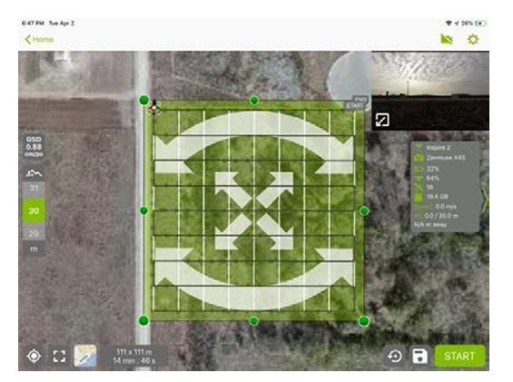
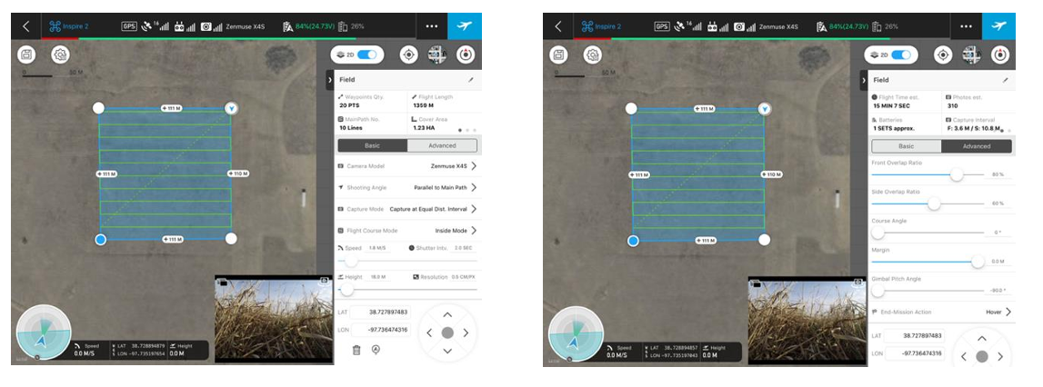
Fig 2: Double-Grid Mission for Forest Scenario
Fig 1: Single-Grid Mission Planning for Field Scenario

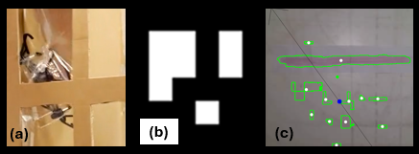
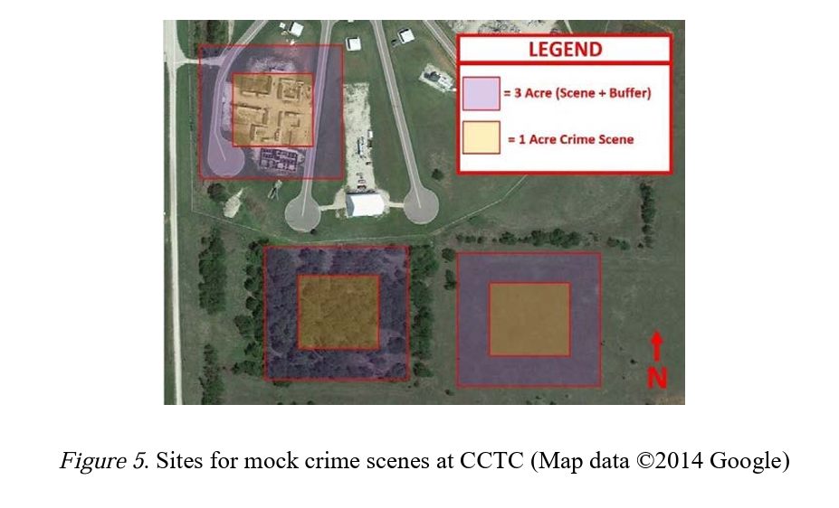
Figure 4: Examples of initial challenges: (a) getting caught, (b) markers not being detected, and (c) false detections in poor illumination
Figure 3: Sites for mock crime scenes at CCTC (Map data ©2014 Google)
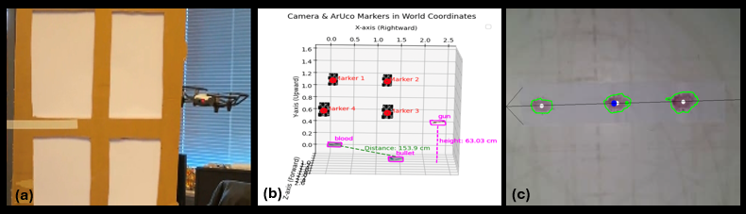
Figure 5: Examples of successful trials: (a) pushing open a window, (b) mapping distances, and (c) inferring direction

Scope of the study
The scope of the study for the research paper would be to look into the usage of drones in crime scene investigation and its impact. The scope of the research would be based on the advanced photogrammetry algorithms in improving crime scene investigation. This paper aims to explain a new concept in autonomous crime scene reconstruction to preserve the crime scene and make the documentation better. This topic has a high potential for research publications in IEEE and forensic science journals.
The future scope of the project would involve AI-based evidence detection and reconstruction.
It could involve machine learning algorithms too.
The use of multiple drones could be explored.
Precautions
- Ensure proper mission planning including all flight parameters overlap settings.
- Follow proper rules and regulations for drone flight operation.
- Avoid damaging any crucial evidence during data collection.
- Check the GPS sensors for verifying GPS signal strength and check the weather condition before drone flight.

Conclusion
To obtain an unbiased decision and to maintain a high-quality mapping of evidence with high precision, there exists a constant need to improve the methodology and techniques of investigation in response to the rise in crime rates and to make the process smoother and better. Any error in the evidence can reduce its use and the scope of the investigation. Managing the crime scene and the forensic investigation requires a lot of skilled experts, manpower, time, and can still be manipulated. To resolve such issues at the crime scene, a drone, which is an unmanned aerial vehicle with functional and operational diversity, can be utilized. With the extensive development in the drone industry, it has been scientifically proven that artificial intelligence can be more efficient in performing certain tasks in comparison to human beings, thus reducing stress and labour on human beings as well. The current research project can be seen as a backbone and a kickstart for the use of UAVs in investigation and crime scene reconstruction.

References

- M. Iqbal, H. Bardwell, and D. Hammond, “Estimating the global economic cost of violence: Methodology improvement and estimate updates,” Defence and Peace Economics, vol. 32, no. 4, pp. 403–426, 2021.
- S. Police, personal communication (project workshop 2024-10-30), 2024.
- E. F. Helbling, S. B. Fuller, and R. J. Wood, “Altitude estimation and control of an insect-scale robot with an onboard proximity sensor,” Robotics Research: Volume 1, pp. 57–69, 2018.
- S. Li, “Visual navigation and optimal control for autonomous drone racing,” Ph.D. dissertation, Delft University of Technology, 2020.
- 2023 IJCSPUB | Volume 13, Issue 1 March 2023 | ISSN: 2250-1770
- Evaluation of Terrestrial Laser Scanning and Aerial Remote Sensing with Small Unmanned Aircraft Systems for Forensic Crime-Scene Reconstruction Kurt J. Carraway
- Staggs, S. (n.d.). Crime Scene and Evidence Photography - Camera and Lighting. Crime Scene and Evidence Photography - Camera and Lighting.

